The server and client both send and receive datagrams using UDP. When executed, the server will create a socket, then wait with that socket open for datagrams. The client will be executed with either a push, pull, or print command.

On a pull, the client sends a pull request to the server, and the server sends a packet of data back to the client. On a push, the client sends a packet to the server, then the server will ACK the packet back to the client. On a print, the client only prints its routing table.

The packet is two parts, header and body. The Header is a short array of length 3, which totals 6 Bytes. The body is a short array of length 4, which totals 8 Bytes. The entire packet is 14 Bytes.

The client has a specified IP and Port, on lines 85, and 136. The server does not specify any IP or Port.

Client printing initial routing table, values for table were not specified in assignment and were set to 9 for testing purposes.
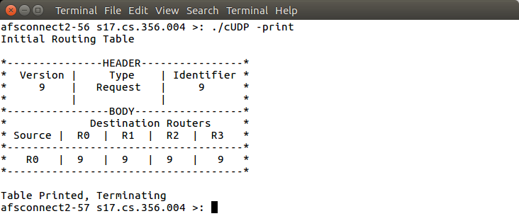
Client pulling data from server. The client sends a datagram to the specified ip on the specified port. It receives the data packet, and prints the result.

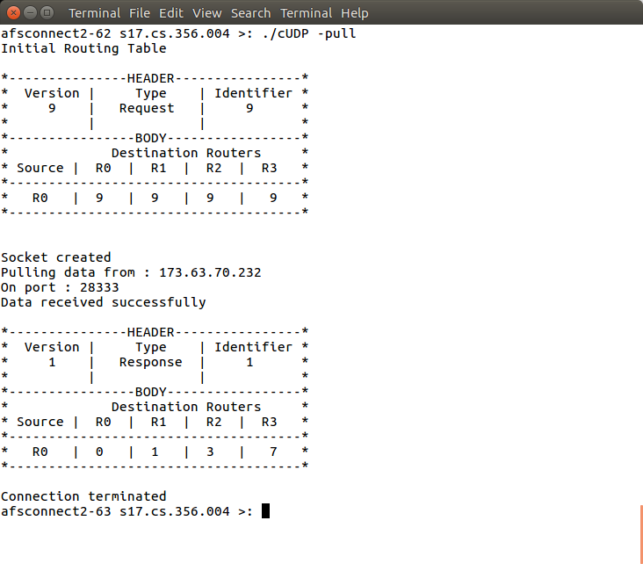

Client pushing data to server. The client sends a datagram to the specified ip on the specified port. The server ACKs the message, and the client prints that the data was successfully sent.

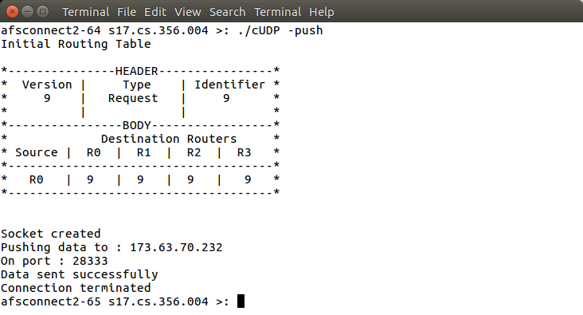
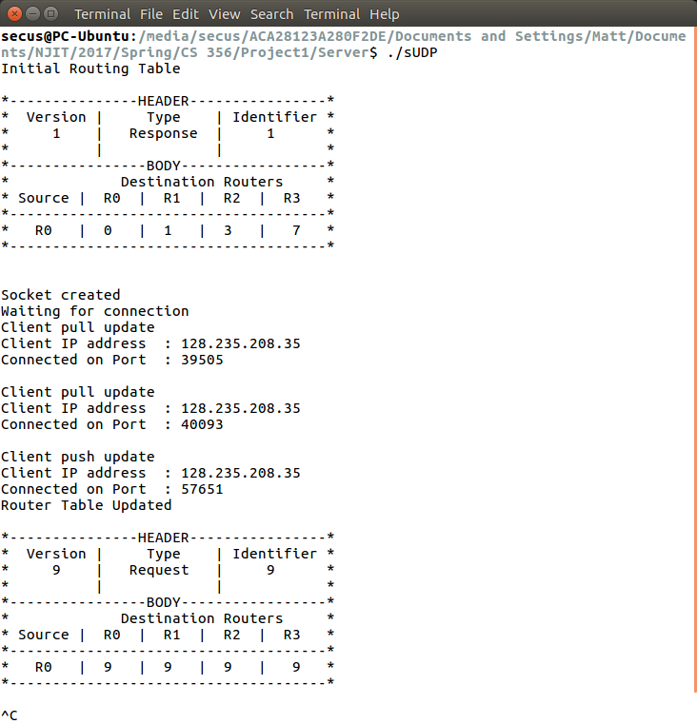
Server result from the client pulling and pushing data to server. The server prints the initial routing table and waits for any datagrams sent to it. When received the server will print a notification showing that a client is either pulling or pushing data. If the client is pushing data, the server will print an updated routing table. The server will remain open for connections until manually closed.

